IMPORTANT: Before you do anything else, please save a new copy of this document with your Group Number in the file name!!! When you finish, make sure to save this as a PDF and upload it to Canvas.

Group Number:

Group Member Names:

SARS-CoV-2 Mutation Mapping

Group Discussion Questions

Before we start plotting data…

- Provide a definition for each of the following common types of mutations. In addition, provide an example of each type of mutation. If the mutation changes an amino acid, show how it does so in your example (you can find a codon table in the “Resources” section below).
  - Missense mutation:
    - Definition:
    - Example:

  - Nonsense mutation:
    - Definition:
    - Example:

  - Silent mutation:
    - Definition:
    - Example:

  - Frameshift mutation:
    - Definition:
    - Example:

- Which kind of mutation (of the 4 we just defined) do you think is most commonly found in a wild population, point mutations or frameshift mutations? Why?

- Which kind of point mutations do you think are most common? Why?

Now we’ll start working with the whole genome data…
- How many mutations are in the UPenn database? Hint: take the number of rows of data and subtract 1 (for the header of the table).

- Based on the data presented, which point mutation class is most common?

- There are two general types of nucleotide substitutions, transitions and transversions. What is the difference between the two?

- What is the GC content of SARS-CoV-2? You’ll have to look this up. An approximate number is ok.

- How does the SARS-CoV-2 genome GC content compare to the GC content of a human genome?

- Why do you think there are so many C → T nucleotide substitutions? Consider the fact that deamination of cytosine is not uncommon in cells.

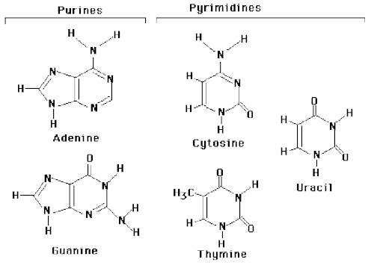

- What is the most common nucleotide substitution that creates a missense mutation? Does this align with the most common type of substitution overall?

- What is the size of the SARS-CoV-2 genome (approximately)?

- What do you see when you look at the distribution of mutations across the whole genome?

- What else would you like to know about these mutations or the virus they came from?

Now let’s look at individual genes…

S gene (Spike)

- What is the function of the S gene?

- What do you see when you look at the distribution of mutations across the S gene?

- Does this give you any ideas about what parts of the S gene are more important than others?

If there is time (E gene [Envelope], M gene [Matrix], or N gene [nucleocapsid]):

- What is the function of your chosen gene?

- Consider questions 15 and 16, but now in the context of your chosen gene, not S. Do your answers change? Why or why not?

Extra Resources

Codon Table
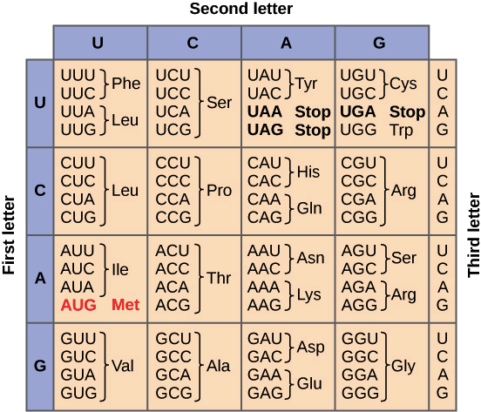
This Khan Academy link has a refresher on how to use a codon table.

Common Mutations

OpenStax Microbiology 11.5: Mutations link

Figures from the presentation

Rplot01: Barplot of each mutation class in the file
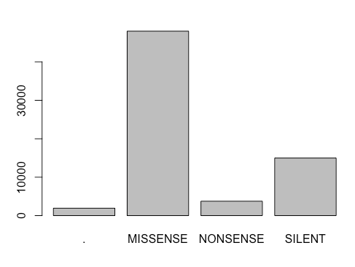

Rplot02: Barplot of each nucleotide change in decreasing order

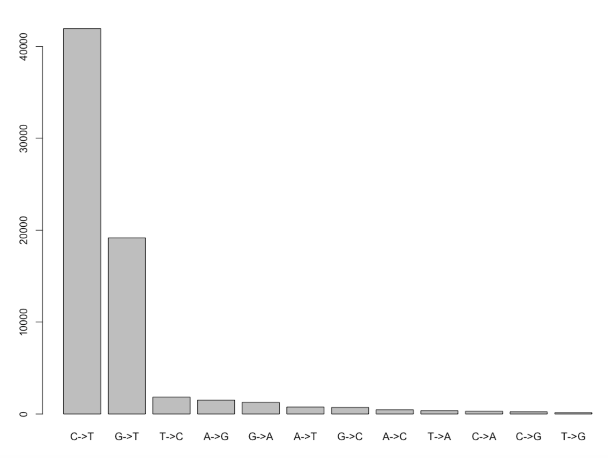

Rplot03: Barplot of each nucleotide change that causes a missense mutation in decreasing order

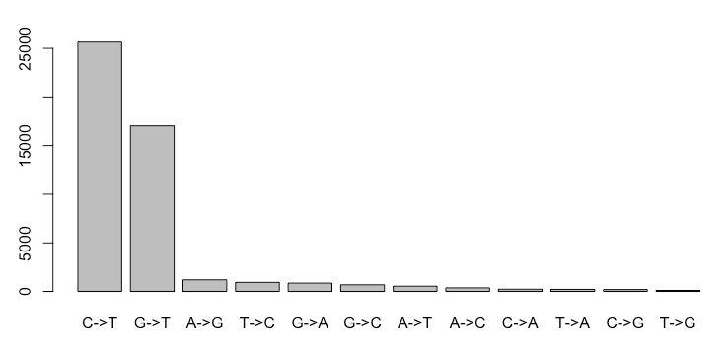

Rplot04: Mutations along the SARS-CoV-2 genome
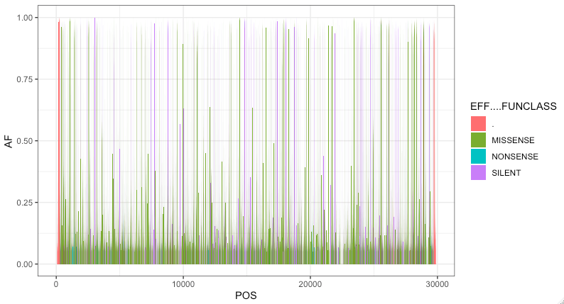

Rplot05: Mutations and genes along the SARS-CoV-2 genome
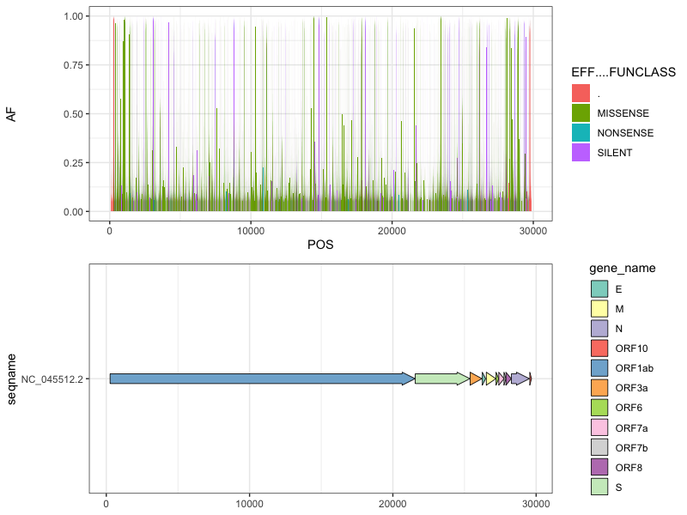

Rplot06: Mutations along the S gene
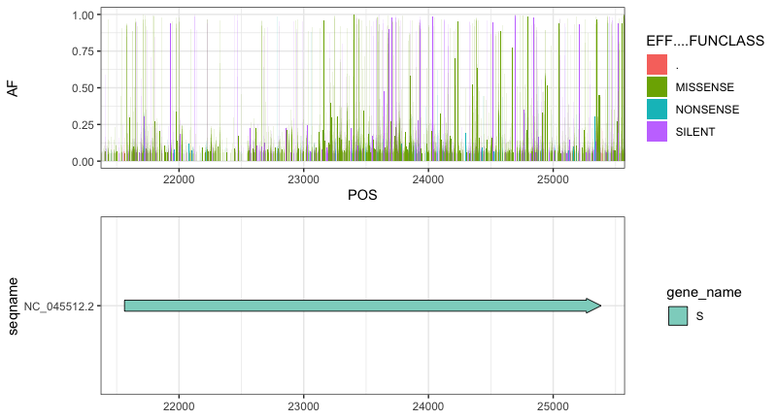

Rplot07: Mutations along the E gene
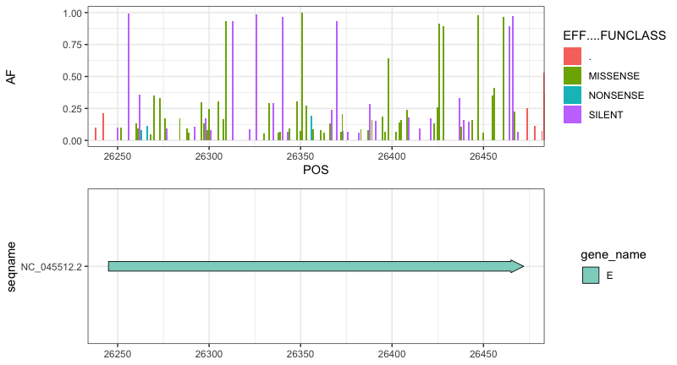

End Message

This is the end of the assignment, please save your file as a PDF and upload it to Canvas before you leave!

